TASK 6 – Course Enrollment (Real-Time Update)
App.js
import React, { useState } from "react";
function App() {
const [course, setCourse] = useState("");
const [courses, setCourses] = useState([]);
const enrollCourse = () => {
if (course !== "") {
setCourses([...courses, course]);
setCourse("");
}
};
return (
<div style={container}>
<h2>Task 6: Course Enrollment</h2>
<input
type="text"
placeholder="Enter course name"
value={course}
onChange={(e) => setCourse(e.target.value)}
/>
<button onClick={enrollCourse}>Enroll</button>
<ul>
{courses.map((c, index) => (
<li key={index}>{c}</li>
))}
</ul>
</div>
);
}

const container = {
width: "400px",
margin: "50px",
padding: "20px",
border: "1px solid #ccc",
};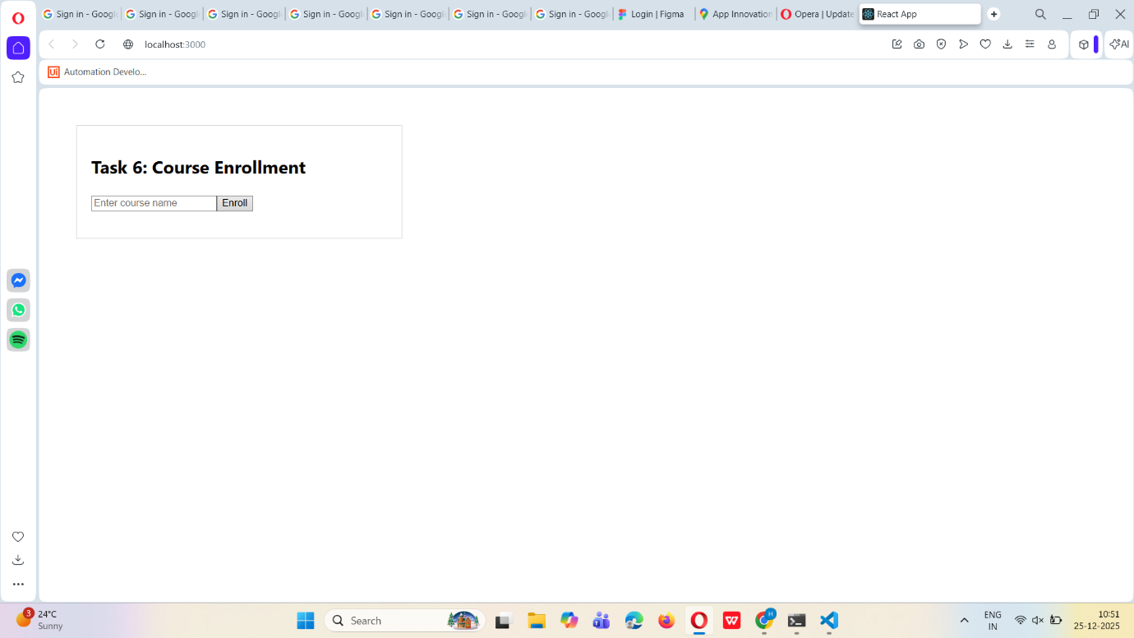
export default App;

